RETAIL PROFITABILITY AUDIT: DEEP-DIVE KEY INSIGHTS & STRATEGY BRIEF

1. Executive Summary & Financial Impact
An end-to-end data architecture was deployed to audit 10,000 retail transactions, transitioning raw logistics and sales data into actionable intelligence. Through SQL database structuring and Python machine learning (K-Means clustering), we uncovered a critical operational bottleneck. Extended warehouse holding times are not just tying up capital—they are mathematically destroying our net margins. If uncorrected, this forced-liquidation cycle threatens to erode up to 22% of aggregate baseline profitability over the next fiscal year.

2. The Core Problem: Inventory Depreciation & Opportunity Cost
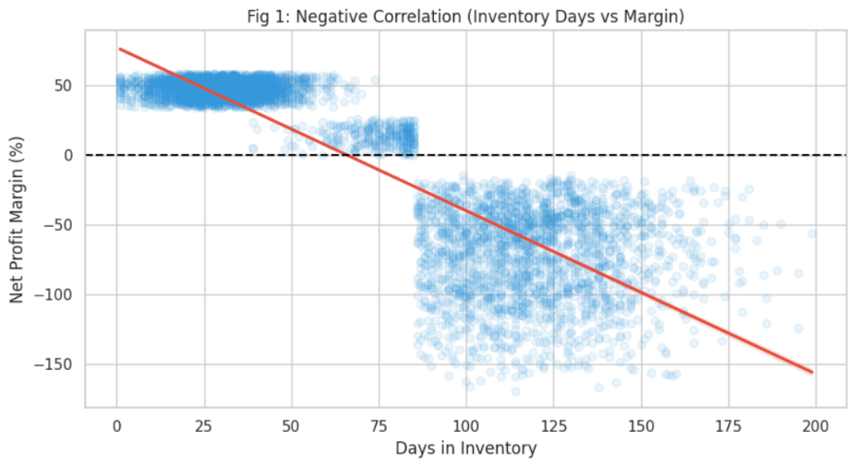

It illustrates a severe, undeniable negative correlation between the days an item sits in the warehouse (DIO) and the realized net profit margin. Products held past 85 days cross a critical threshold where storage fees and market irrelevance force aggressive liquidation discounts (ranging from 35% to 65%). This not only results in negative profit margins on the items sold but creates a massive "Opportunity Cost"—warehouse space that could be used for high-margin electronics is being squandered on dead stock furniture.

3. Identifying the Danger Zones via AI Risk Clustering
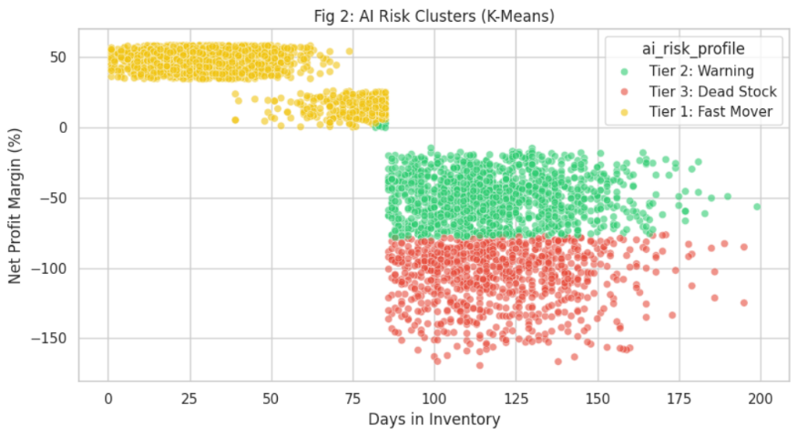

Utilizing K-Means machine learning, we successfully segmented our entire global inventory into three distinct risk tiers (Figure 2). The model definitively proved that our "Furniture" category almost exclusively populates the red "Tier 3: Dead Stock" cluster. Relying on gut intuition for stock clearance is no longer required; we now have a mathematical boundary that flags inventory the moment it becomes a financial liability.

4. Macro-Logistics & Supply Chain Vulnerability
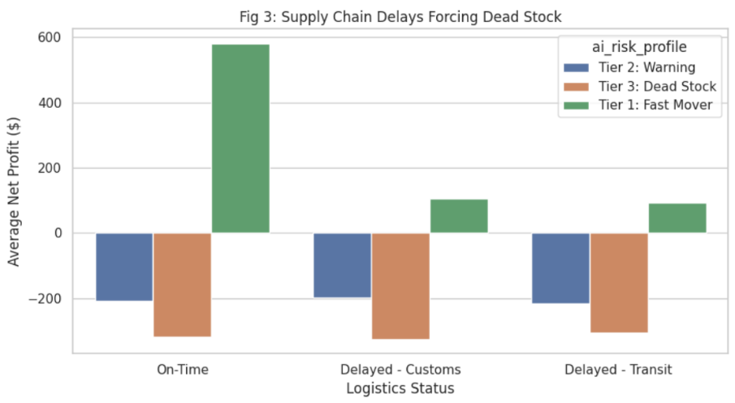

The operational drag is heavily exacerbated by external supply chain shocks. Figure 3 highlights that items flagged in our SQL database as "Delayed - Customs" almost universally bypass "Tier 1: Fast Mover" status and fall directly into the Tier 3 danger zone. A shipping delay of just 14 days is enough to completely wipe out the profit margin of an otherwise highly lucrative electronics asset.

5. Seasonal Profit Cycles & Peak Capital Allocation
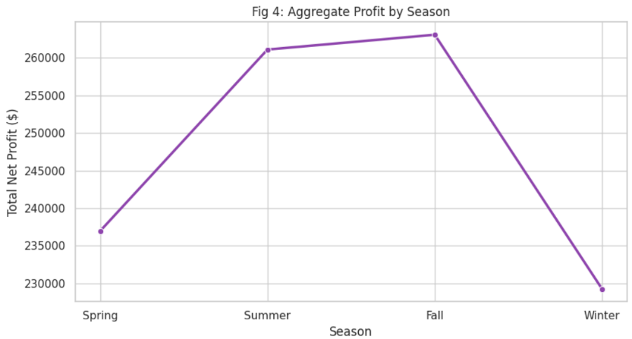

It outlines aggregate profit behavior across the calendar year. Recognizing these peaks is vital for capital allocation. We are currently over-purchasing slow-moving inventory during off-peak seasons, leaving us cash-poor when high-velocity "Summer" and "Winter" demand spikes occur.

6. Comprehensive Strategic Action Plan
To immediately reverse margin erosion, operations must execute the following KPIs:
- Phase-Out Flat Discounts (Dynamic Bundling): Immediately discontinue flat 50% clearance sales on Tier 3 stock (e.g., Desks, Tables). Instead, implement Point-of-Sale (POS) dynamic bundling. Attach these stagnant items to highly elastic Tier 1 items (e.g., Computers) at a slight aggregate discount. This clears warehouse space while protecting the blended profit margin.
- Just-In-Time (JIT) Transition: Shift procurement capital away from the Furniture category and establish a strict Just-In-Time (JIT) replenishment model for Tier 1 Apparel and Electronics.
- Customs Buffer: Renegotiate lead times with overseas vendors to account for the "Delayed - Customs" variable, ensuring high-margin items hit the shelves before crossing the 85-day depreciation threshold.

